**PATIENT MANAGEMENT SYSTEM**

**A PROJECT REPORT**

**for**

**Mini Project (KCA353)**

**Session (2023-24)**

**Submitted by**

**PRAJJWAL YADAV**

**(University Roll No:- 2200290140111)**

**Submitted in partial fulfilment of the**

**Requirements for the Degree of**

**MASTER OF COMPUTER WEBSITELICATION**

**Under the Supervision of**

**Dr. Shashank Bharadwaj**

Associate Professor



**Submitted to**

**Department Of Computer Applications**

**KIET Group of Institutions, Ghaziabad**

**Uttar Pradesh-201206**

**(December 2023)**

**CERTIFICATE**

Certified that **Prajjwal Yadav 2200290140117** has/ have carried out the project work having “**PATIENT MANAGEMENT SYSTEM**” for **Master of Computer Applications** from Dr. A.P.J. Abdul Kalam Technical University (AKTU**)** (formerly UPTU), Lucknow under my supervision. The project report embodies original work, and studies are carried out by the student himself/herself and the contents of the project report do not form the basis for the award of any other degree to the candidate or to anybody else from this or any other University/Institution.

**Date: 23 Feb 2024**

**Prajjwal Yadav (2200290140111)**

This is to certify that the above statement made by the candidate is correct to the best of my knowledge.

**Date: 23 Feb 2024**

**Dr. Shashank Bharadwaj Dr. Arun Tripathi**

**Associate Professor Head**

**Department of Computer Applications Department of Computer Applications**

**KIET Group of Institutions, Ghaziabad KIET Group of Institutions, Ghaziabad**

**Prajjwal yadav**

**ABSTRACT**

A Patient Management System (PMS) is a comprehensive software solution designed to streamline and enhance the efficiency of healthcare facilities in managing patient information and healthcare processes. The abstract of a Patient Management System typically highlights key features and functionalities, emphasizing its role in improving overall patient care, administrative tasks, and decision-making processes within a healthcare organization. Here is a generalized abstract:

The Patient Management System (PMS) is a sophisticated software website developed to address the complex needs of modsern healthcare institutions. This system is designed to facilitate seamless and efficient management of patient information throughout the entire healthcare continuum. Key features include electronic health record (EHR) management, website appointment scheduling, billing and invoicing, prescription management, and reporting functionalities.

The PMS aims to improve patient care by providing healthcare professionals with quick and easy access to comprehensive and up-to-date patient records. This not only enhances the accuracy of diagnoses and treatment plans but also promotes a higher level of patient engagement and satisfaction.

Administratively, the system automates various tasks such as website appointment scheduling and billing, reducing the administrative burden on healthcare staff and minimizing the likelihood of errors. The PMS also supports efficient communication among healthcare providers, ensuring a coordinated and collaborative website approach to patient care.

**ACKNOWLEDGEMENT**

Success in life is never attained single handedly. My deepest gratitude goes to my thesis supervisor, **Dr. Shashank Bhardwaj** for his guidance, help and encouragement throughout my research work. Their enlightening ideas, comments, and suggestions.

Words are not enough to express my gratitude to Dr. Arun Kumar Tripathi, Professor and Head, Department of Computer Website for his insightful comments and administrative help at various occasions.

Fortunately, I have many understanding friends, who have helped me a lot on many critical conditions.

Finally, my sincere thanks go to my family members and all those who have directly and indirectly provided me moral support and other kind of help. Without their support, completion of this work would not have been possible in time. They keep my life filled with enjoyment and happy.

**PRAJJWAL YADAV**

**TABLE OF CONTENTS**

|  |  |  |  |
| --- | --- | --- | --- |
|  | Certificate | | ii |
|  | Abstract | | iii |
|  | Acknowledgements | | iv |
|  | Table of Contents | | v |
|  | List of Tables | | vi |
|  | List of Figures | | vii |
|  |  | |  |
| 1 | Introduction | | 8-14 |
|  | 1.2 | Key Features | 1 |
|  | 1.3 | Project Description | 3 |
|  |  | 1.4 Project Scope | 5-9 |
| 2 | Feasibility Study | | 10-18 |
|  | 2.1 | Types of feasibility | 6-7 |
|  | 2.1.1 | Technical Feasibility | 7 |
|  | 2.1.2 | Economic Feasibility | 8 |
| 3 | Design | | 10-20 |
|  | 3.1 | System Architecture | 12 |
|  | 3.2 | Use Case Diagram | 13 |
|  | 3.3 | Work Breakdown Structure | 14 |
|  | 3.4 | Flowchart | 15 |
|  | 3.5 | Data Table | 16-17 |
|  | 3.6 | Data Flow Diagram | 18 |
|  | 3.7 | ER Diagram | 19-20 |
| 4 | Form |  | 21-26 |
| 5 | Coding |  | 27-50 |
| 6 | Testing |  | 51-52 |
|  | Bibliography | | 53 |
|  | References | | 54 |

**LIST OF TABLES**

**Table No. Name Of Table Page No.**

2.1 Schedule Feasibility 21

3.2.1 Patient’s Table 23

3.2.2 Doctor’s Table 24

3.5 Type of data 34

3.6 Data Dictionary 34

3.8.1 Patient’s Login 36

3.8.2 Website Appointment 37

3.8.3 Doctor’s Login 38

3.8.4 Prescription 38

3.8.5 Admin Table 39

**LIST OF FIGURES**

**Figure No. Name of Figure Page No.**

3.1 PMS Explore by Patient’s 22

3.3 Flowchart 25

3.4 Use Case Diagram 26

3.5.1 Zero level DFD 28

3.5.2 First level DFD 31

3.5.3 Second Level DFD 33

3.7 ER Diagram 35

4.1 Dashboard Credential Form 40

4.2 Register As a Patient 41

4.3 Registe As a Doctor 42

4.4 Verify doctor page 43

4.5 Doctor’s Registration 43

4.6 Patient’s Login 44

4.7 Patient’s Register 44

4.8 Patient’s Appointment 45

4.9 Doctor’s Login 46

4.10 Book Appointment 47

4.11 Found Doctor 47

4.12 Reset Password 48

4.13 Book Appointment after login of patient 48

4.14 Doctor’s dashboard to check app 49

4.15 Book Appointment acc to timing and shift 49 after login of patient

4.16 Payment dashboard to generate bill 50

4.17 App is successfully done by patient 50

**CHAPTER 1**

**INTRODUCTION**

**1.1 INTRODUCTION**

Hospitals are the essential part of our lives which provides us with the best medical facilities for various sickness, it may be due to the change in climatic conditions, stress (emotional trauma) etc. It is necessary for the hospital to keep track of all activities and records day in and day out of its patient, doctors, nurses and other staffs that keeps the hospital in its operation

Keeping track of all activities and reports on paper is very inefficient and time consuming and also error prone. Keeping records on paper is a traditional base system that sometimes do not make it robust, in any case of damage all files will be lost that will cost a lot to the organization Day in and day out many people visit the hospital and when using the traditional base system it make it unreliable in the sense that it will take longer time to enter or access data and also maintaining. It is not economically and technically feasible to maintain these records on paper.

Patient Management System (PMS) is a comprehensive web-based designed to streamline healthcare facilities and enhance patient management. This project aims to provide a centralized platform that allows doctors, patients, and clinic administrators to efficiently manage medical records, website appointments, and communication.

The primary objective of the Patient Management System is to improve the patient experience, optimize healthcare provider efficiency, and maintain accurate and secure medical records. By leveraging technology, the system simplifies the management of healthcare facilities and enhances the overall quality of care provided.

**1.2 KEY FEATURES**

**1.2.1 Patient Registration:**

* Capture and store patient demographic information. Assign unique identifiers to each patient for easy tracking.

**1.2.2 Website appointment Scheduling:**

* Schedule and manage patient website efficiently. Provide reminders to patients about upcoming website appointments.

**1.2.3 Electronic Health Records (EHR):**

* Maintain comprehensive digital health records for each patient. Include medical history, diagnoses, medications, allergies, and test results.

**1.2.4 Billing and Invoicing:**

* Generate and manage patient invoices. Integrate with billing systems for insurance claims processing.

**1.2.5 Security and Compliance:**

* Ensure the system complies with healthcare data security standards (such as HIPAA).Implement role-based access controls to protect patient information.

**1.2.6 Mobile Accessibility:**

* Support mobile access for healthcare professionals on the go. Allow patients to access certain features through a mobile website. Create and manage digital prescriptions. Integrate with pharmacies for seamless prescription processing.

**1.3 PROJECT DESCRIPTION**

Patient Management System is a comprehensive and management website developed to address the challenge associated with dividing and overseeing shared financial obligations within social or professional circles. The primary goal of this website to provide users with a seamless and efficient solution for handling the complexities of shared expenses, offering a user-friendly interface and a range of features to enhance financial coordination.

Users of Patient Management System can easily initiate and manage groups tailored to specific shared activities, such as household bills, group outings, or collaborative projects. The website’s intuitive design allows participants to keep track of individuals contributions and monitor the overall financial landscapes within the group. This transparency is a key aspect of Patient Management System aiming to foster clear communication and reduce potential misunderstandings related to shared finances.

One of the standout features of Patient Management System is its robust expense tracking system. Users can input and categorize various expenses, providing detailed information such as the nature of the cost, date and the involved participants.

This features not only aids in accurate record-keeping but also facilitates a comprehensive understanding of the financial dynamics within the group. The website’s quick bill-splitting functionalities further contribute to its efficiency. Patient Management System automates the process of dividing costs among participants, eliminating the need for manual calculations and ensuring that each member’s financial contributions accurately reflected. This automation not only saves time but also minimizes the like hood of errors in the distribution of expenses.

Real-time updates on financial contributions add another layer of convenience to patients. Participants can stay informed about the current state of fostering a sense of safeguard sensitive financial information, ensuring a trustworthy platform for users.

**1.4 PROJECT SCOPE**

The project scope for Patient Management System entails the development and deployment of a comprehensive and management website. Users will have the ability to register and create individual accounts, ensuring a personalized experience within the website. Robust authentication mechanisms will be implemented to safeguard user data and maintain the security of the platform.

A central feature of the website is the creation and a management of expenses groups. Users can effortlessly initiate and oversee financial collaborations related to shared activities, such as household bills, group outings, or collaborative projects. Each expense group will provide a dedicated space for participants, enabling transparent communication and coordination.

The website will boast an intuitive interface for detailed expense tracking. Users can input and categorize various expenses, including relevant details such as the nature of the cost, date and involved participants. The features ais to streamline record-keeping and facilities a comprehensive understanding of the financial dynamics within each group.

To further enhance efficiency, the website will automate the process of splitting bills among participants. This functionality eliminates the need for manual calculations, ensuring accurate and fair distribution of expenses. Real-time updates on financial contributions will be provided, fostering a sense of accountability and collaboration within each expense group.

Overall, the Patient Management System will offer a seamless and user-friendly solution for managing shared finances, promoting transparency, accuracy, and ease of use for individuals navigating shared financial responsibilities.

Automation will be a key feature, particularly in the process of splitting bills among participants. The website will employ algorithms to calculate and distribute expenses automatically, eliminating the need for manual calculations and minimizing the potential for errors. Real-time updates on financial contributions will be integrated to keep participants informed, fostering a sense of accountability and collaboration within each group.

**1.5 HARDWARE / SOFTWARE USED IN PROJECT**

The Patient Management System will involve a combination of hardware and software components to ensure its development, deployment and functionality. Here’s detailed List.

**1.5.1 SERVER-SIDE HARDWARE:**

**1.5.1.1 RAM (Random Access Memory):**

* 8GB to 16GB (for moderate-sized website and user load).
* Consider higher capacities (e.g., 32GB or more) for scalability and handling large numbers of concurrent users.

**1.5.1.2 ROM (Storage):**

* SSD storage for faster read and write operations.
* Allocate storage based on the website codebase, database size, and media storage requirements.

**1.5.1.3 PROCESSOR:**

* Multi-core processor (quad-core or higher) for efficient handling of concurrent user requests.

**1.5.1.4 OPERATING SYSTEM:**

* Linux-based operating system (e.g., Ubuntu Server, CentOS, Debian) for stability and performance.

**1.5.1.5 NETWORK EQIPMENTS:**

* Network infrastructure to facilitate secure data transfer between users and the server.

**1.5.2 DATABASE SERVER:**

**1.5.2.1 RAM:**

* 16GB or more for efficient handling of concurrent database queries.

**1.5.2.2 ROM(Storage):**

* SSD storage for faster data retrieval.
* Allocate storage based on the anticipated size of the database and data storage needs.

**1.5.2.3 PROCESSOR:**

* Multi-core processor with sufficient processing power for complex database operations.

**1.5.2.4 OPERATING SYSTEM:**

* Linux-based operating system for the database server.

**1.5.3 USER DEVICES:**

**1.5.3.1 SMARTPHONES/TABLETS:**

* Compatibility with iOS and Android operating systems.
* Optimization for various screen sizes and resolutions.

**1.5.3.2 Web Browsers:**

* Compatibility with major web browsers such as Google Chrome, Mozilla Firefox, Safari, and Microsoft Edge.

**1.5.4 DEVELOPMENT ENVIRONMENT:**

**1.5.4.1 Programming Languages:**

* Backend: Python, Node.js or another suitable language.
* Frontend: HTML5, CSS3, JavaScript (React, Angular, Vue.js).

**1.5.4.2 Framework:**

* Web framework (e.g., Flask, Django, Express.js) for backend development

**1.5.4.3 Database Management System:**

* Choose a suitable DBMS (e.g., MySQL, PostgreSQL, MongoDB) for efficient data storage and retrieval.

**1.5.4.4 Authentication and Authorization:**

* Implement secure authentication protocols (OAuth, JWT) and authorization mechanisms.

**1.5.4.5 APIs:**

* Develop APIs to enable communication between the frontend and backend components.

**1.5.4.6 Version Control:**

* Version control system (e.g., Git) for managing and tracking changes in the source code.

**1.5.4.7 Integrated Development Environment (IDE):**

* IDEs such as Visual Studio Code, or IntelliJ IDEA for coding and debugging.

**1.5.4.8 Containerization:**

* Containerization tools like Docker for efficient deployment and scalability.

**1.5.4.9 Continuous Integration/Continuous Deployment (CI/CD) :**

* CI/CD pipelines (e.g., Jenkins, Travis CI) for automated testing and deployment.

**1.5.4.10 Security Tools:**

* Integrate security tools and practices to ensure the website resilience against potential threats.

**1.5.4.11 Monitoring Tools:**

* Monitoring tools (e.g., Prometheus, Grafana) for tracking website performance.

**1.5.4.12 Collaboration Tools:**

* Collaboration tools (e.g., Slack, Microsoft Teams) for effective communication among project team members.

**CHAPTER 2**

**FEASIBILITY STUDY**

**2.1 INTRODUCTION**

The feasibility study Patient Management System for the is a critical initial phase in the project lifecycle, aiming to assess the viability and practicality of implementing the proposed management solution. This study encompasses a comprehensive analysis of various aspects, including technical, economic, legal, operational, and scheduling considerations.

In an era characterized by dynamic financial interactions and collaborative living, the concept of managing has become increasingly complex. Recognizing the need for a streamlined solution, the Patient Management System is envisioned as a comprehensive tool to alleviate the challenges associated with dividing and managing shared financial responsibilities.

This feasibility study is undertaken to evaluate the practicality and potential success of developing and implementing the Patient management system.

The primary objective of the feasibility study is to provide a thorough examination of the technical, economic, legal, and operational aspects involved in bringing the Patient management system to fruition. By conducting this study, we aim to gain insights into the project's viability, potential challenges, and anticipated benefits. The study will serve as a foundation for informed decision-making throughout the development lifecycle.

**2.2 KEY OBJECTIVES**

**2.2.1 Technical Feasibility**:

* Assess the technical requirements and challenges associated with developing the Patient Management System.
* Evaluate the availability of necessary technologies and expertise to implement the proposed features.

**2.2.2 Economic Feasibility**:

* Examine the cost implications of developing and maintaining the Patient Management System.
* Project the Return on Investment (ROI) and assess the financial viability of the project.

**2.2.3 Legal Feasibility**:

* Investigate legal considerations, including data protection, privacy laws, and compliance requirements.
* Ensure that the development and deployment of the website adhere to regulatory standards.

**2.2.4 Operational Feasibility**:

* Analyze how the Patient Management System will integrate into existing operational processes.
* Evaluate the website’s usability and acceptance by potential users.

**2.2.5 Scheduling Feasibility**:

* Develop a realistic project timeline, considering the development, testing, and deployment phases.
* Identify potential bottlenecks and risks that may impact the project schedule.

**2.3 Technical Feasibility**

The technical feasibility assessment is a pivotal component of the Patient Management System, project, focusing on the viability and capability of implementing the proposed solution from a technological standpoint.

This analysis delves into various technical aspects, including infrastructure requirements, software development considerations, and potential challenges. The goal is to ascertain whether the envisioned website can be developed effectively, leveraging available technologies and expertise.

**2.3.1 Infrastructure Requirements:**

* **Server Infrastructure:** Asses the capacity and scalability of cloud-based servers (e.g., AWS, Azure) to accommodate potential user growth and ensure seamless performance.
* **Database Management**: Evaluate the suitability of database systems (e.g., MySQL, SQL) for efficient storage and retrieval of user data.

**2.3.2 Software Development:**

* **Programming Languages:** Choose website backend (e.g., Python, Node.js) and frontend (e.g., React, Angular) technologies based on developer expertise and project requirements.
* **Framework Selection**: Select a web website framework (e.g., Django, Flask) to streamline development and enhance maintainability.

**2.3.3 Security Measures:**

* Authentication Protocols: Implement secure authentication mechanisms (e.g., OAuth, JWT) to protect user accounts and ensure data security.

**2.3.4 User Interface (UI) Design:**

* **Responsive Design:** Optimize the website's UI for various devices (smartphones, tablets, web browsers) to provide a consistent and user-friendly experience.

**2.3.5 Deployment and Monitoring:**

* **Docker:** Implement containerization using Docker for efficient deployment, scalability, and consistency across different environments.

**2.4 Operational Feasibility**

The operational feasibility analysis is a crucial aspect of determining whether the Patient Management System can seamlessly integrate into existing processes and effectively meet the needs of its users.

This assessment involves evaluating usability, acceptance, and overall practically from and operational standpoint.

**2.4.1 User Acceptance:**

* **User Feedback Surveys:** Conduct surveys or gather feedback from potential users to gauge their acceptance of the Patient Management System. Understand user preferences and expectations.

**2.4.2 Usability Testing:**

* **User Interface (UI) Testing:** Evaluate the user interface for intuitiveness and ease of use. Conduct usability testing to identify any potential issues in navigation or functionality.

**2.4.3 User Engagement Strategies:**

* **Communication Plans:** Develop communication strategies to keep users informed about new features, updates, and any changes in the website. Foster ongoing engagement.

**2.4.4 Operational Impact Analysis:**

* **Operational Workflow Analysis:** Assess how the Patient Management System will fit into users' daily workflows. Identify potential impacts on existing operational processes.

**2.4.5 Change Management Strategies:**

* **Change Management Plans:** Develop strategies to manage organizational and user-level changes resulting from the introduction of the Patient Management System. Address any potential resistance.

**2.4.6 Legal and Compliance Considerations:**

* **Compliance Analysis:** Ensure that the website complies with relevant legal and regulatory requirements related to financial transactions, data protection, and user privacy.

**2.5 Behavioral Feasibility**

The behavioral feasibility analysis of the Patient Management System focuses on understanding and anticipating the attitudes, perceptions, and cultural dynamics that may influence user acceptance and adoption. A key consideration in the success of the website is the motivation of potential users to incorporate it into their shared financial management practices.

This involves evaluating whether users perceive the website as a valuable solution to their needs and whether it aligns with their motivations for collaborative expense management. Cultural acceptance is another critical aspect, where the website's features and communication strategies need to resonate with cultural preferences.

Adaptations may be necessary to ensure the website is well-received within diverse user communities. Effective communication strategies are vital to convey the benefits of the Patient Management System clearly. Outreach efforts should aim to inform potential users about how the website addresses pain points and simplifies shared financial responsibilities.

Understanding and addressing resistance to change is imperative, as users may be accustomed to existing methods of expense management. Change management strategies should be implemented to ease concerns and foster a positive attitude towards adopting the website.

Moreover, user education and awareness campaigns play a pivotal role in ensuring that potential users are well-informed about the website's features and advantages. User-centric design principles guide the development of the Patient Management System, taking into account user preferences and behaviors.

User experience research informs the refinement of the website's interface for optimal usability, creating an environment that is intuitive and engaging for a diverse user base. Consideration of social dynamics in shared living or collaborative work environments is also paramount, with the website designed to enhance social interactions related to financial activities.

To further encourage user acceptance, the website incorporates feedback mechanisms, providing users with a platform to contribute their insights. Incentive structures, such as rewards for active participation, are explored to motivate users and enhance behavioral acceptance.

The Patient Management System also places a strong emphasis on accessibility and inclusivity, ensuring that it caters to users with diverse needs and abilities. By addressing these behavioral aspects comprehensively, the Patient Management System seeks not only to meet the functional needs of users but also to align seamlessly with their behaviors, preferences, and motivations.

This user-centric website approach is fundamental to fostering positive user attitudes, driving adoption, and ensuring the long-term success of the website in shared financial management scenarios.

**2.6 Schedule Feasibility**

The schedule feasibility analysis for the Patient Management System is integral to the project's success, aiming to assess the practicality and achievability of the proposed timeline. A meticulously planned project timeline delineates key milestones, deliverables, and deadlines across the development, testing, and deployment phases. Each stage, including development, testing, and iterative cycles, undergoes detailed task breakdowns to ensure accurate time allocation for coding, testing, and refinement.

Testing and quality assurance constitute critical phases, demanding ample time for comprehensive testing, debugging, and issue resolution. Incorporating iterative development cycles and feedback loops allows for continuous refinement based on testing outcomes and user feedback. The availability of human resources, including developers and testers, is carefully considered to ascertain that team members can commit the necessary time to their respective roles.

In anticipating potential risks, the schedule feasibility analysis identifies technical challenges, resource constraints, and unforeseen issues, accompanied by mitigation strategies to minimize their impact. Exploring parallel development opportunities and incorporating contingency buffers in the schedule further fortifies the project against unexpected delays.

Finally, the schedule feasibility analysis recognizes the iterative nature of development, allowing for the integration of user feedback into the process. This iterative website ensures that the Patient Management System aligns closely with user expectations, resulting in a well-executed project within the stipulated timeframe.

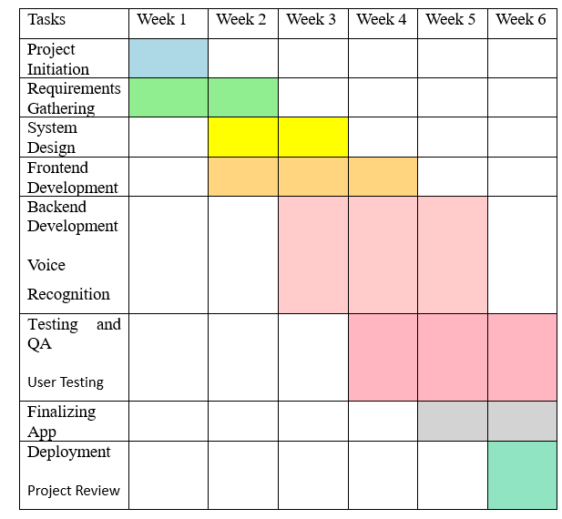

Figure 2.1 Schedule Feasibility (Gantt Chart)

**CHAPTER 3**

**DATABASE DESIGN**

**3.1 INTRODUCTION**

The database design for the Patient Management System is a foundational element that a pivotal role in organizing and managing data efficiently. A well-structured database is essential for facilitating seamless interactions between the website and its uses, ensuring robust data storage, retrieval and manipulation. The introduction outlines of the fundamental principles guiding the database design process and emphasizes the importance of creating a scalable and secure data architecture to support the diverse needs of expense management within collaborative settings.

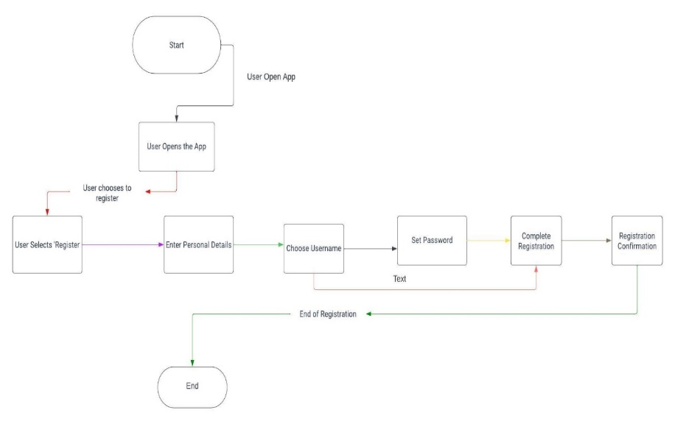

Figure 3.1 PMS Explore by Patient

**3.2 DATABASE TABLES**

Creating a comprehensive database table for the Patient Management System

considering the key entities and their attributes. In a simplified example, let's focus on two main entities: Users and Expenses. Here's a basic representation:

**3.2.1 Patient Table:**

* **Patient id (Primary Key):** Unique identifier for each user.
* **email:** User’s email address for communicate and login.
* **name:** User’s full name.
* **patient password:** Securely hashed password for authentication.
* **phone number:** User’s contact number.

|  |  |  |  |  |
| --- | --- | --- | --- | --- |
| Patient  id | Email | Patient  name | Patient pass | phone number |
| 1 | John.sheng2097@gmail.com | John | #2122223fsdx | 9368563885 |
| 2 | [a@gmail.com](mailto:a@gmail.com) | Abhir | #3c2223rsdx | 8321563885 |
| 3 | Akash.kumar2097@gmail.com | Akash | #2122253ftdx | 9462563885 |

Figure 3.2.1 Patient's Table

**3.2.2 Doctor Table:**

* **Website appointment Date:** Date when the expense was incurred.
* **Deducted Amount:** Amount deducted from patient account.
* **Description:**  Title for each budget expenses.
* **User name:** Akash
* **Fees:** 500

|  |  |  |  |
| --- | --- | --- | --- |
| **Website appointment Date** | **Deducted Amount** | **Fees paid** | **Description** |
| 2024-01-09 | 100 | 500 | Coffee party |
| 2023-01-09 | 1000 | 600 | College fees |
| 2024-02-09 | 100 | 750 | Rent |

Figure 3.2.2 Doctor’s Table

**3.3 FLOWCHART**

The flowchart for the patient management system encapsulates the intricate

sequence of actions and decision points involved in its operation, providing a visual roadmap for understanding the systematic flow of activities. At its core, the flowchart delineates the stepwise processes initiated by user interactions, the validation and categorization of expense data, communication with the database, and the subsequent generation and presentation of expense reports.

Commencing with the entry point, often represented by the user’s interaction, the flowchart systematically guides through essential processes such as user registration, login, expense entry, and report generation. Decision points within the flowchart capture instances where the system evaluates conditions, such as validating user data or verifying login credentials, influencing the subsequent course of actions. Key processes, depicted in distinct shapes and connected by arrows, convey the logical flow from one operation to another.

For instance, the flowchart delineates how the Patient management system communicates with the database for tasks like storing and retrieving user and expense data. Decision diamonds illustrate branches in the logic, signifying points where the system evaluates conditions and proceeds accordingly.

This visual representation not only aids developers in understanding the operational logic but also serves as a valuable tool for stakeholders to grasp the intricacies functionality. The flowchart serves as a blueprint, guiding the development team through the systematic execution of tasks, ensuring that the website functions cohesively and efficiently. Ultimately, the Patient management system flowchart is a pivotal resource in comprehending, communicating, and refining the logical sequence of processes within the system.

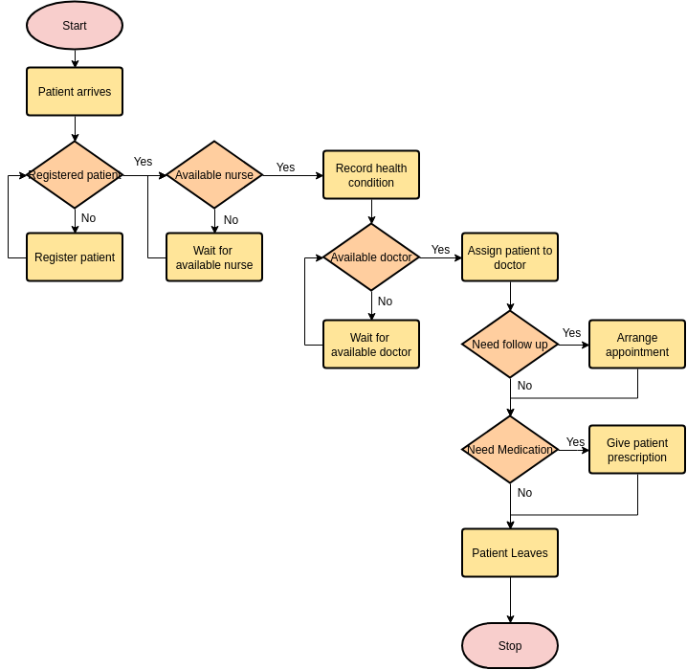

Figure 3.3 Flowchart Diagram for Patient management system

**3.4 USE CASE DIAGRAM**

The Use Case Diagram for the patient management system serves as an the very best

illustrative depiction of the key functionalities and interactions between various actors within the system. Central to this diagram are the primary actors—the “User or Patient and the “Doctor”—with the “Database” playing a supportive role.

The “User” actor, representing individuals engaging with the website, initiates essential use cases such as registering an account, logging in, entering expenses, viewing detailed reports, generating summaries, and securely logging out.

On the other side, the “Patient Management system” actor, the central web application these interactions, undertakes critical use cases like validating user data during registration, creating user accounts, verifying user credentials during login, handling expense entry and categorization, and retrieving data for reporting purposes. The “Database” actor, as an external entity, collaborates with the patient management system to store user and expense data, forming a cohesive system. This Use Case Diagram provides a high-level overview of the system's behavior, offering a foundational understanding for stakeholders, developers, and designers as they navigate the development and interaction aspects of Patient Management system.

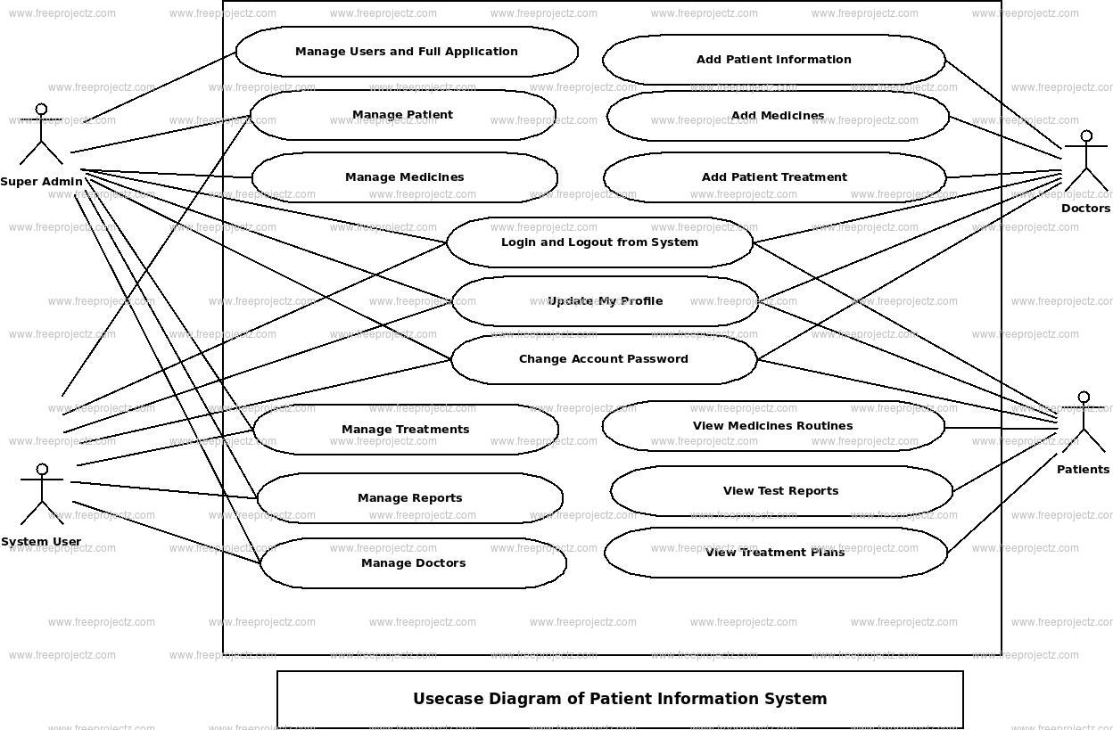

Figure 3.4 Use Case Diagram for Patient management system

**3.4.1 Actors:**

* User
* System

**3.4.2 Use Case:**

* Select Mode
* Login
* Forgot Password
* Reset Password
* Sign Up
* Verify Email
* Open Dashboard
* Add Doctors
* View Reports

In the patient management system, when the user opens the mode selection web page, they encounter two choices: Patient and Doctor. If the user clicks on normal patient, a login page of website where the user is prompted to enter their email and password. After entering the credentials, the user clicks on the login button, leading them to the dashboard. In the event that a user forgets their password, they can initiate the password reset process. The user is required to enter their email, and a verification code is sent to their email address.

After receiving the verification code, the user enters it and then proceeds to reset their password. Once the new password is set, the user can log in using the updated credentials.

For users who do not have an account, they can click on the signup option. During signup, the user is prompted to provide details such as their name, email, password, and budget limit. After entering this information, a verification code is sent to the user's email.

If a user wishes to review their transaction history, they can click on the report option. This allows the user to access and view their transaction report.

**3.5 DATA FLOW DIAGRAM**

The Data Flow Diagram (DFD) for the Patient Management System provides a good

visual representation of the flow of data within the system, illustrating how information moves between various components. At its core, the DFD encapsulates the key processes, data stores, and data flows involved in the expense management website. Starting with user inputs, such as registering, logging in, and entering expense details, the diagram delineates how these interactions trigger processes like data validation, expense calculations, and database updates. The DFD also portrays the storage and retrieval of user data in the database, emphasizing the seamless exchange of information between users and the website.

By encapsulating the fundamental data movements and transformations, the DFD serves as a valuable blueprint for understanding the Patient Management System's operational dynamics.

**3.5.1 Level 0 Data Flow Diagram**

PATIENT

MANAGEMENT

DOCTOR

MANAGEMENT

MEDICINE

MANAGEMENT

DISEASES

MANAGEMENT

TEST

MANAGEMENT

DOCTOR SCHEDULE

MANAGEMENT

Figure 3.5.1 Level 0 DFD of Patient Management System

The Level 0 Data Flow Diagram (DFD), also known as the Context Diagram **(Fig. 3)**, serves as a high-level representation of the Patient Management system, portraying it as a singular process and illustrating the interactions between the system and external entities. The primary entities involved in this context are the User, the Database (where expense data is stored), and the Patient Management system itself.

**3.5.1.1 Entities:**

* **User:** Represents the individuals utilizing the Patient management system for tasks such as registration, add doctors and make website appointment.
* **Patient management system.** Represents the central website that users interact with to perform various tasks related to expense management.
* **Database:** Signifies the repository where expense data is stored, facilitating secure and organized data management.

**3.5.1.2 Processes:**

* **User Interaction with the Expense Analyzer Website:** This process encapsulates the various tasks that users can perform within the , including registration, expense entry, and report generation.
* **Communication with the Database:** The Patient management system communicates with the Database to store and retrieve expense data efficiently, ensuring data accuracy and consistency.

**3.5.1.3 Data Flow:**

* Users input and retrieve data directly from the Patient management system , enabling seamless interaction and data manipulation within the website.

**3.5.2 Level 1 Data Flow Diagram**

At the more detailed Level 1 Data Flow Diagram (DFD), the User process is systematically broken down into distinct sub-processes, offering a granular view of the specific task’s users can perform within the Patient management system. This detailed breakdown further refines the interactions between the User, Database, and Patient Management system entities

**3.5.2.1 Entities:**

* **Patient:** Represents individuals engaging with the Patient Management system for various tasks.
* **Database:** The storage facility for expense data, ensuring secure and organized data management.
* **Patient records.:** The central website facilitating user interactions and managing communication with the database.

**3.5.2.2 Processes:**

* **Patient Registration:** Sub-process wherein a user registers on the Patient management system by providing necessary details. Involves validation of user-provided information and updating the database with new user details.
* **Patient Login:** Sub-process allowing registered users to log into the Patient Management system securely.Involves user authentication and validation against stored credentials in the database.
* **Enter :** Sub-process enabling users to input new expense data into the Patient Management System. Involves validation of entered expense details and updating the database with the new expense entry.
* **View Patient Report:** Sub-process where users can retrieve and view detailed reports of their expenses. Involves querying the database for relevant expense data and presenting it to the user through the Expense Analyzer Website.
* **Logout:** Sub-process enabling users to securely log out of the Patient management system. Ensures the proper termination of the user session.

**3.5.2.3 Data Flow:**

* Users interact with the Patient Management system to execute specific tasks, ranging from registration to generating expense summaries.
* The Patient Management system , acting as the intermediary process, communicates with the Database to retrieve or update expense data based on user actions.
* For instance, during User Registration, user details are sent to the Database for storage.

GENERATE PATIENT REPORT

PATIENT

MANAGEMENT

GENERATE MEDICINE

REPORT

MEDICINE

MANAGEMENT

GENERATE TEST

REPORT

TEST

MANAGEMENT

DOCTOR SCHEDULE

MANAGEMENT

GENERATE DOCTOR

SCHEDULE REPORT

CHECK DISEASE

DETAILS

DISEASES

MANAGEMENT

DOCTOR

MANAGEMENT

GENERAE DOCTOR

REPORT

Figure 3.5.2 Level 1 DFD of Patient Management System

**3.5.3** **Level 2 Data Flow Diagram**

At the Level 2 Data Flow Diagram (DFD), the detailed breakdown of each user process provides a more intricate view of the sub-processes involved in specific tasks within the Patient Management system. This level of detail offers insights into the intricacies of data flow and interactions between the User, Database, and Patient Management System entities**.**

**3.5.3.1 Entities:**

* **User:** Represents individuals interacting with the Expense Analyzer Website for various tasks.
* **Database:** The storage facility for expense and user data, ensuring secure and organized data management.
* **Patient Management system:** The central website facilitating user interactions and managing communication with the database.

**3.5.3.2 Processes:**

* **Validate User Data:** Sub-process involves checking the validity of user-provided information during the registration process.
* **Create User Account:** Sub-process for creating a new user account, involving the storage of validated user data in the database.
* **Verify User Credentials:** Sub-process for authenticating user credentials during the login process.
* **Validate Expense Data:** Sub-process ensuring the accuracy and integrity of the entered patient data.
* **Categorize Expense:** Sub-process involving the selection and assignment of expense categories for better organization.
* **Calculate Expense Totals:** Sub-process involving the computation of total expenses based on the retrieved data.
* **Generate Summary Report:** Sub-process for creating a summarized report based on the calculated totals.
* **Calculate Expense Totals:** Sub-process involving the computation of total expenses based on the retrieved data.
* **Generate Summary Report:** Sub-process for creating a summarized report based on the calculated totals.
* **Logout:** Sub-process enabling users to securely log out of the Patient Management system, terminating the user session.

**3.5.2.3 Data Flow:**

* Each sub-process communicates with the Patient Management system and may involve interactions with the database.
* For instance, during User Registration, the validated user data is communicated to the Patient management system, which, in turn, communicates with the database to store the new user account.

MANAGE PATIENT

DETAILS

ADMIN

MANAGE MEDICINE

DETAILS

MANAGE TEST

DETAILS

MANAGE DOCTOR

SCHEDULE DETAILS

MANAGE DISEASES

DETAILS

MANAGE DOCTOR PROFILES

MANAGE REPORT

MANAGE ROLES FOR

USERS

MANAGE USER

PERMISSION

MANAGE SYSTEM

ADMINS

Figure 3.5.3 Level 2 DFD of Patient Management System

|  |  |  |
| --- | --- | --- |
| 1. | legal_character | [a-z|A-Z] |
| 2. | Digit | [0-9] |
| 3. | special_ch | [@|$|#|+|-] |
| 4. | Blood | [A|B|AB|O] |

Table 3.5 Type of Data

|  |  |  |
| --- | --- | --- |
| 1. | Name | first_name+(middle_name)+last_name |
| 2. | first_name | {legal_character}* |
| 3. | middle_name | {legal_character}* |
| 4. | last_name | {legal_character}* |
| 5. | P_ID | {legal_character+digit}* |
| 6. | D_ID | {legal_character+digit}* |
| 7. | A_ID | {legal_character+digit}* |
| 8. | Password | {legal_character+digit+special_ch}* |
| 9. | Address | House_no+(Street)+City |
| 10. | House_no | {legal_character+digit}* |
| 11. | Street | {legal_character}* |
| 12. | City | {legal_character}* |
| 13. | MobileNo. | {digit}* |
| 14. | Blood_Group | {Blood+special_ch}* |
| 15. | Specialization | {legal_character}* |
| 16. | ConsultantFee | {digit}* |
| 17. | Medicine | {legal_character+digit}* |
| 18. | Advice | {legal_character+digit}* |
| 19. | Remark | {legal_character+digit}* |

**3.6 DATA DICTIONARY**

Table 3.6 Data Dictionary

**3.7 ER DIAGRAM**

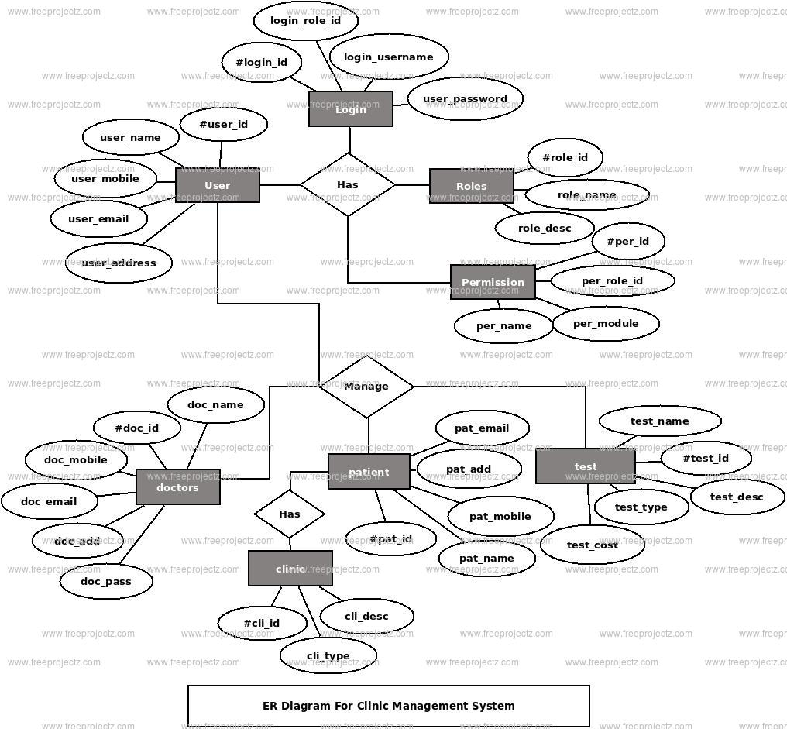

Figure 3.7 ER Diagram of Patient Management System

**3.8 DATA DESIGN**

|  |  |  |  |  |
| --- | --- | --- | --- | --- |
| **SNO.** | **COLUMNNAME** | **DATATYPE** | **CONSTRAINTS** | **DESCRIPTION** |
| 1. | Patient’s id | Varchar(50) | Primary Key | ContainsUniqueId |
| 2. | Name | Varchar(50) | **-** | ContainsName |
| 3. | DOB | Varchar(50) | **-** | ContainsDateOf  Birth |
| 4. | Gender | Varchar(50) | **-** | ContainsGender |
| 5. | Email ID | Varchar(50) | **-** | ContainsEmailId |
| 6. | Address | Varchar(50) | **-** | ContainsAddress |
| 7. | Mobile No. | Integer | **-** | ContainsMobileNo. |

Table 3.8.1 Patient’s login

|  |  |  |  |  |
| --- | --- | --- | --- | --- |
| **SNO.** | **COLUMNNAME** | **DATATYPE** | **CONSTRAINTS** | **DESCRIPTION** |
| 1. | Doctor’s id | Varchar(50) | Primary Key | Contains UniqueId  Patient |
| 2. | Specialization | Varchar(50) | **-** | Contains Name of the Department in which  Patient wants to visit |
| 3. | Doctor’s Name | Varchar(50) | **-** | Contains Doctor Name Patient Wants  To Visit |
| 4. | Consultant Fee | Integer | **-** | Contains Consultant  Fee Of Doctor |
| 5. | Date | Date | **-** | Contains Date For  The Websiteointment |
| 6. | Time | Time | **-** | Contains Time For  The Websiteointment |

Table 3.8.2 Website appointment

|  |  |  |  |  |
| --- | --- | --- | --- | --- |
| **SNO.** | **COLUMNNAME** | **DATATYPE** | **CONSTRAINTS** | **DESCRIPTION** |
| 1. | Doc’s Id | Varchar(50) | Primary Key | ContainsuniqueID |
| 2. | Age | Integer | **-** | Containsage |
| 3. | Gender | Varchar(50) | **-** | Containsgender |
| 4. | Specialization | Varchar(50) | **-** | Contains  Specialization |
| 5. | Experience | Varchar(50) | **-** | Containsexperienceofthedoctor  (Inmonths) |
| 6. | Language | Varchar(50) | **-** | Contains in howmanylanguages  doctorcanspeak. |
| 7. | Mobile No. | Integer | - | Containsmobile  Number |
| 8. | Email ID | Varchar(50) | **-** | ContainsEmailId |
| 9. | Schedule | Varchar(50) | **-** | Contains day andtimeforwhichthe  Doctorisavailable |

Table 3.8.3 Doctor Login

|  |  |  |  |  |
| --- | --- | --- | --- | --- |
| **SNO.** | **COLUMNNAME** | **DATATYPE** | **CONSTRAINTS** | **DESCRIPTION** |
| 1. | D_ID | Varchar(50) | - | ContainsuniqueID |
| 2. | P_ID | Varchar(50) | Primary Key | ContainsuniqueID |
| 3. | Medicine | Varchar(50) |  | Containsnameofthe  medicine. |
| 4. | Remark | Varchar(50) |  | Contains Remarkgivenbythedoctor  forthepatient. |
| 5. | Advice | Varchar(50) |  | Contains any advice  For the patient. |

Table 3.8.4 Prescription

|  |  |  |  |  |
| --- | --- | --- | --- | --- |
| **SNO.** | **COLUMNNAME** | **DATATYPE** | **CONSTRAINTS** | **DESCRIPTION** |
| 1. | A_ID | Varchar(50) | Primary Key | ContainsuniqueID. |
| 2. | Name | Varchar(50) | **-** | ContainsName |
| 3. | DOB | Varchar(50) | **-** | ContainsDateOf  Birth |
| 4. | Gender | Varchar(50) | **-** | ContainsGender |
| 5. | Email ID | Varchar(50) | **-** | ContainsEmailId |
| 6. | Mobile No. | Integer | **-** | ContainsMobileNo. |
| 7. | Address | Varchar(50) | **-** | ContainsAddress |

Table 3.8.5 Admin

|  |  |  |  |  |
| --- | --- | --- | --- | --- |
| **SNO.** | **COLUMNNAME** | **DATATYPE** | **CONSTRAINTS** | **DESCRIPTION** |
| 1. | P_ID | Varchar(50) | - | ContainsuniqueID. |
| 2. | Bill No. | Varchar(50 | Primary Key | Containsnumberof  thebill. |
| 3. | Date | Varchar(50 | - | ContainsDateofThe  bill. |
| 4. | Time | Varchar(50 | - | ContainsTimeofthe  billgenerated. |

**CHAPTER 4**

**FORM DESIGN/SCREENSHOTS**

**4.1 INTRODUCTION**

The form design for the Patient Management System is a fundamental aspect that governs the user interface, providing a structured and intuitive framework for users to input and interact with data. This design aims to create a seamless and user-friendly experience by organizing elements such as text fields, dropdowns, and buttons in a visually website and logically arranged manner. Users engage with the form to register, log in, and input expense details, and the design emphasizes clarity, simplicity, and efficiency in capturing accurate information. By carefully considering user input requirements, validation processes, and responsive design principles, the form design ensures a positive user experience, encouraging user engagement and fostering effective communication between users and the website.

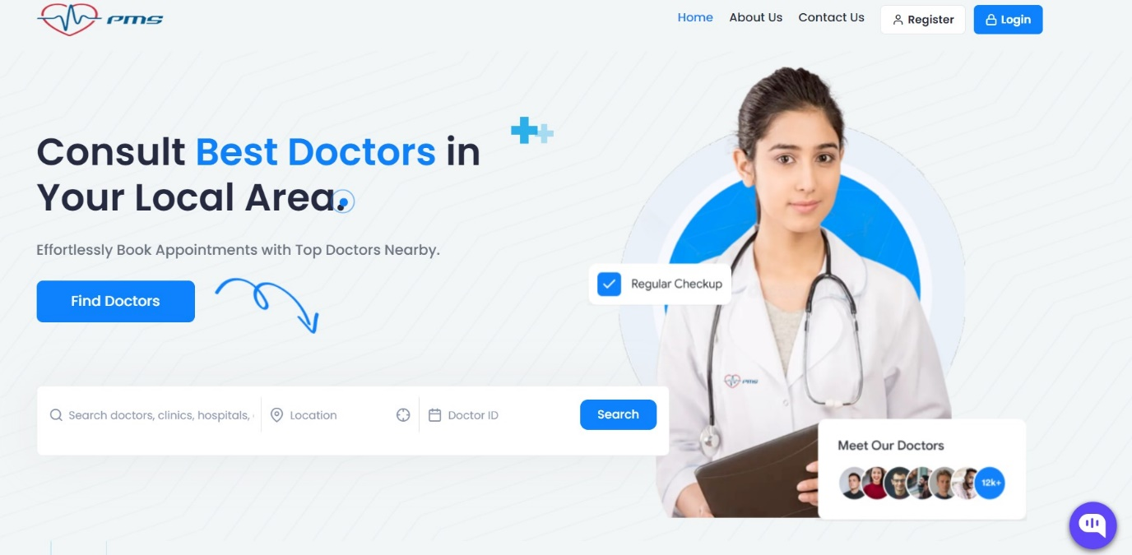



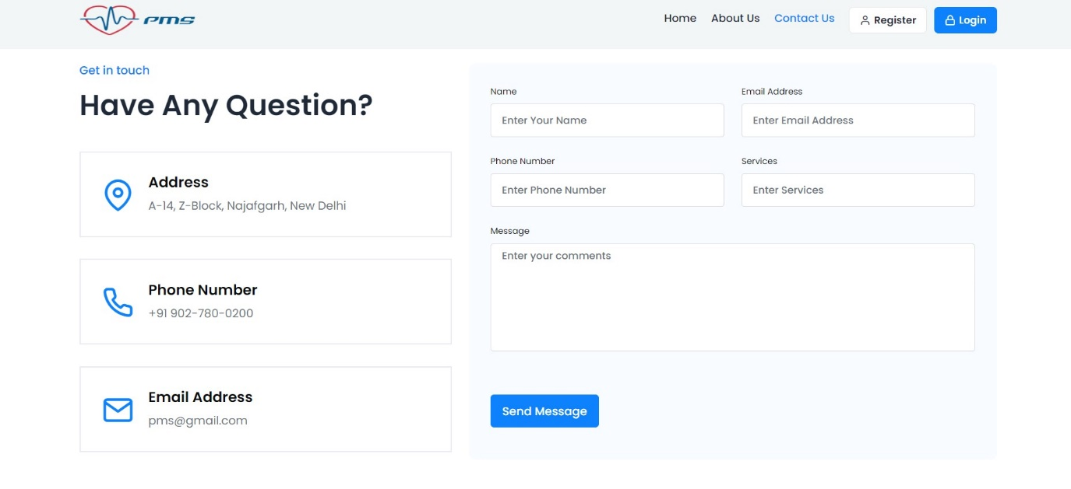

Figure 4.1 Dashboard Credentials form

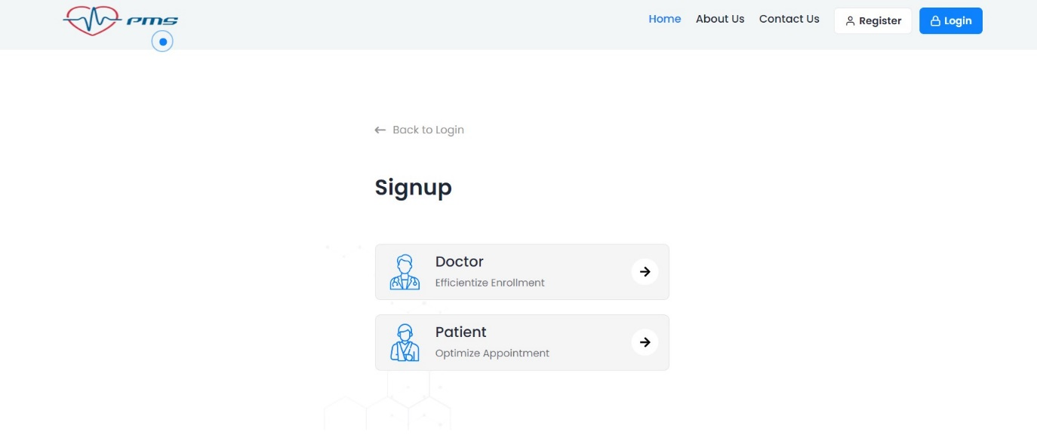

Figure 4.2 Register as a Patient/Doctor

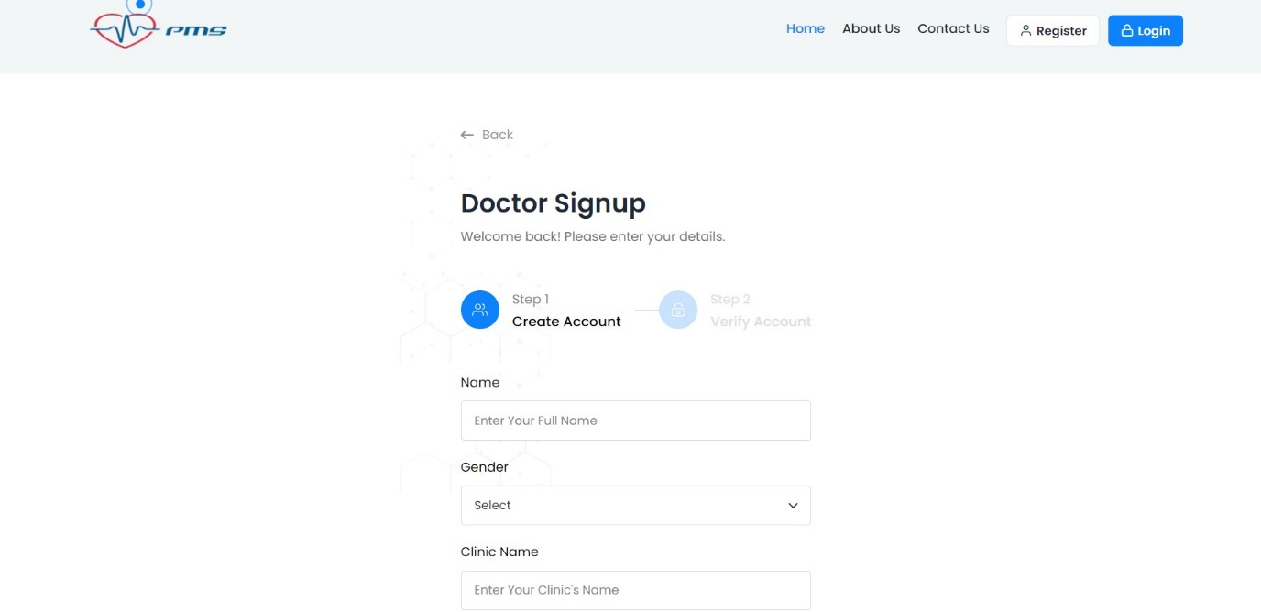

Figure 4.3 Register as a Doctor Page

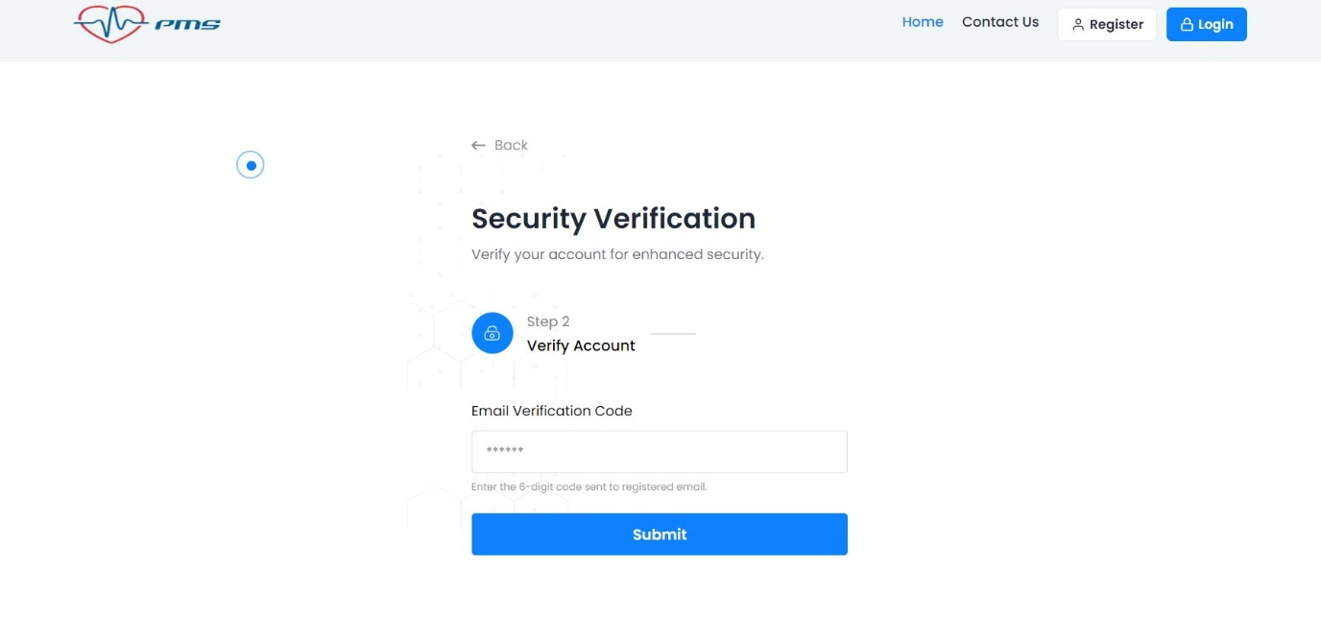

Figure 4.4 Verify as a Doctor Page

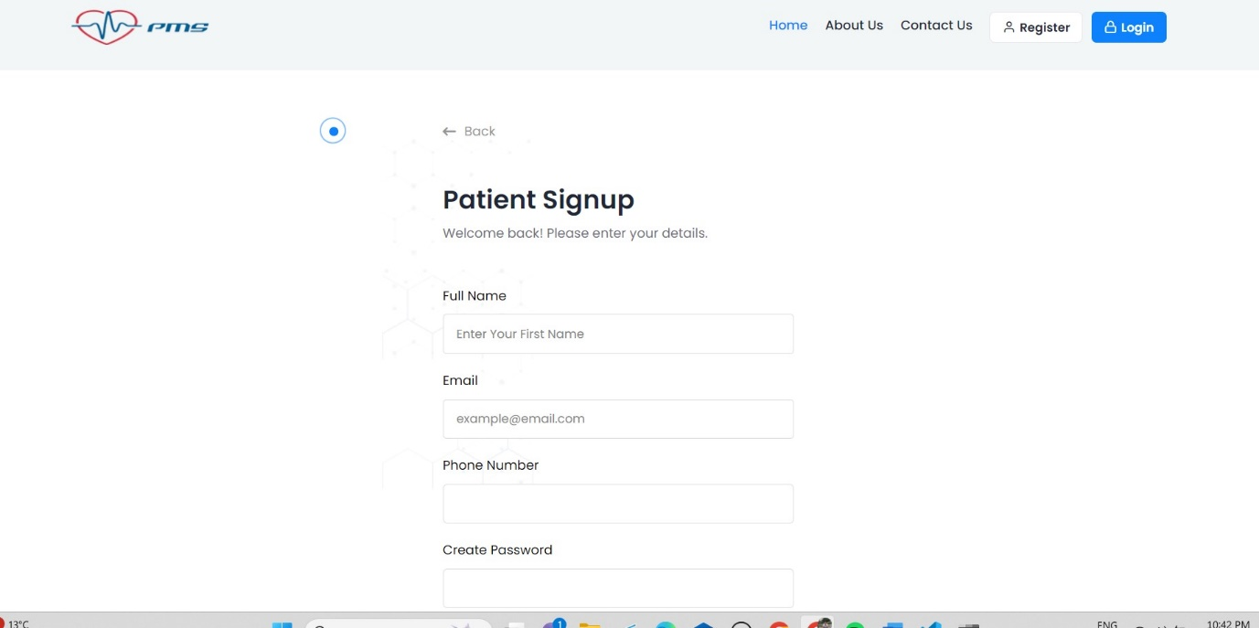

Figure 4.5 Register as a Doctor Page

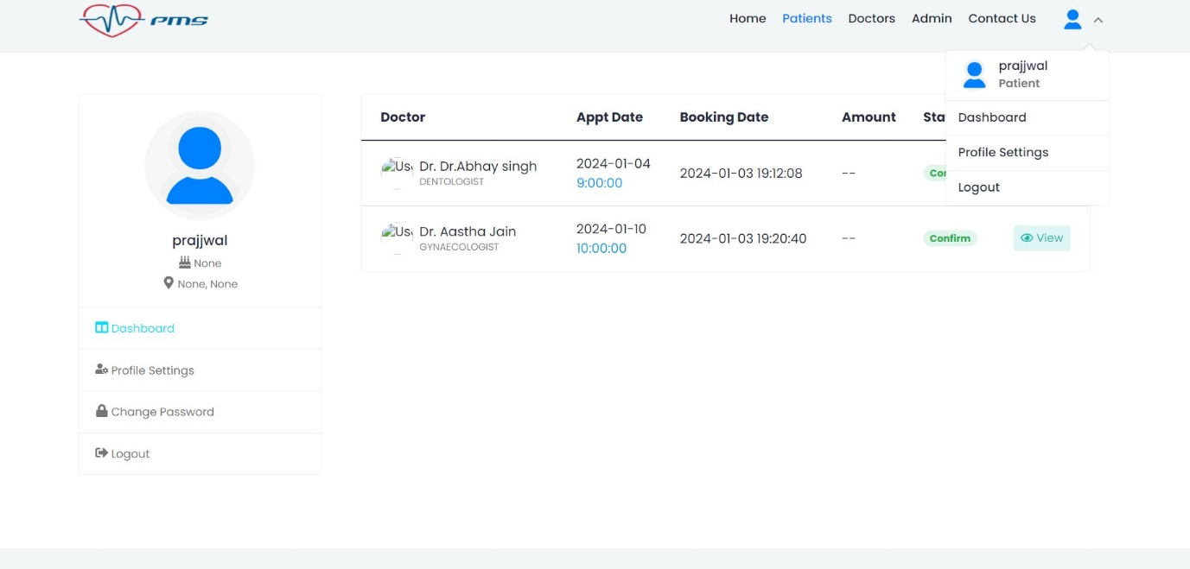

Figure 4.6 Login as a Patient Page

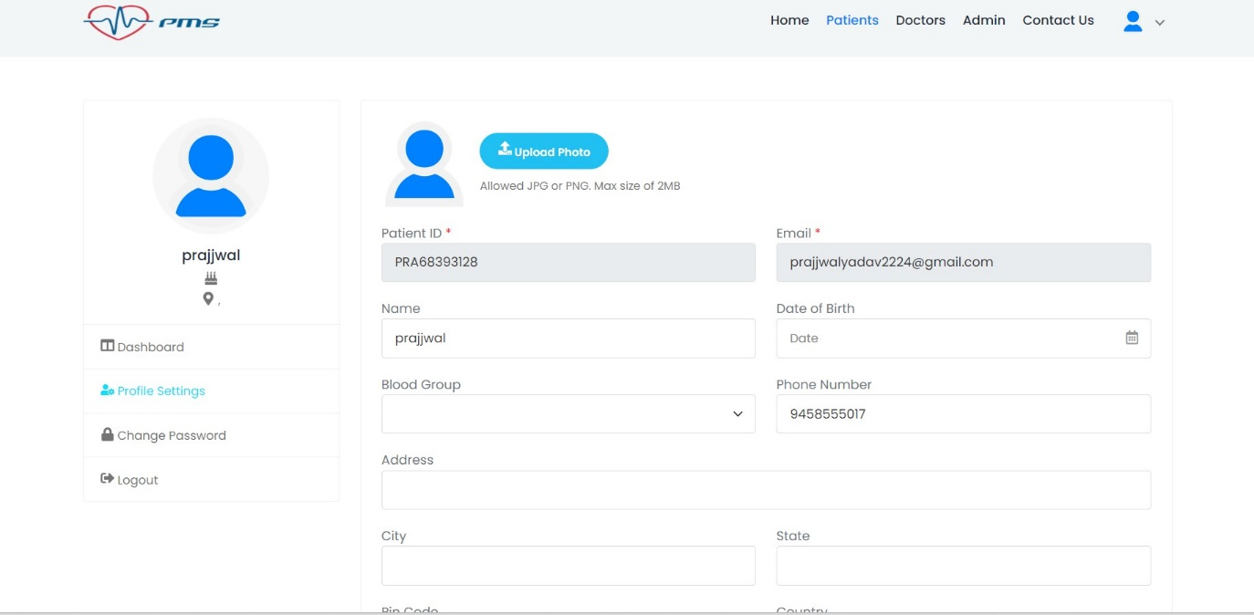

Figure 4.7 Login as a Patient Page

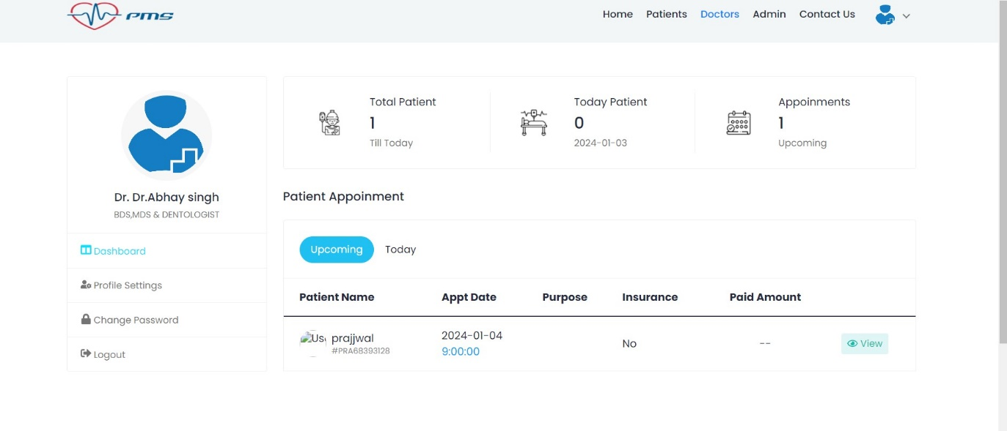

Figure 4.8 Website appointment of a Patient Page

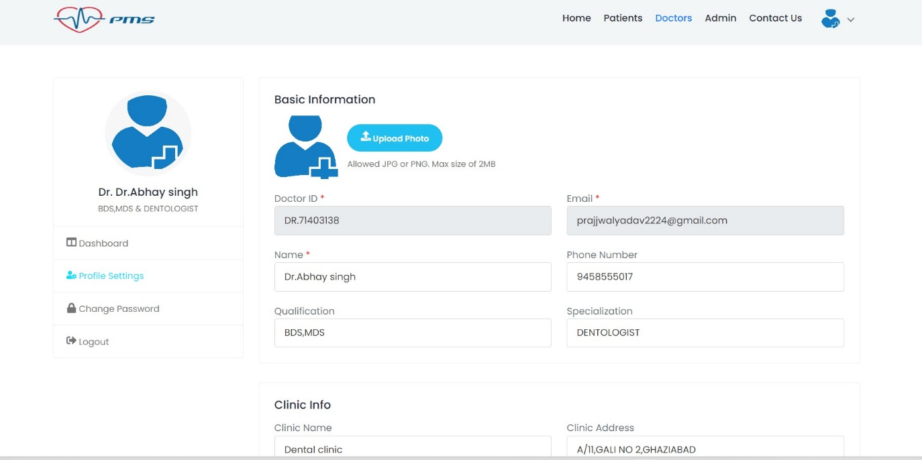

Figure 4.9 Login as a Doctor Page

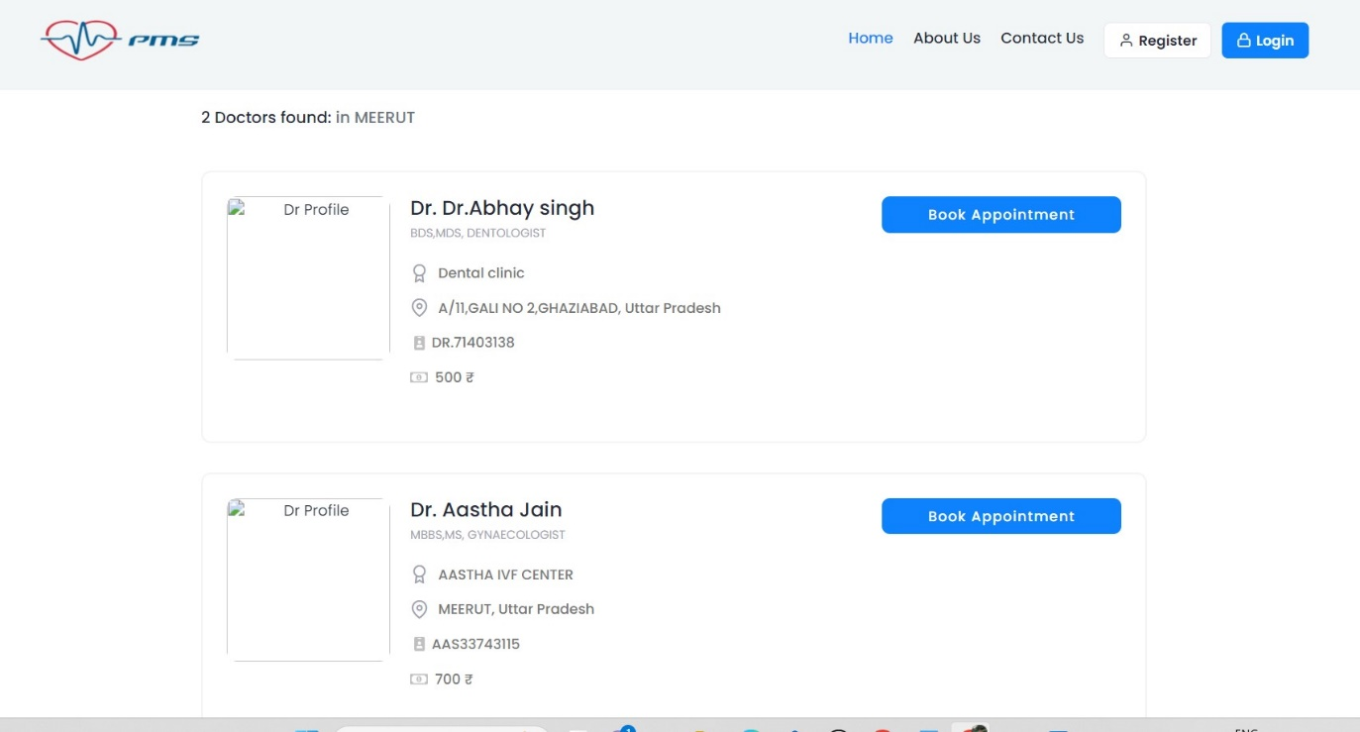

Figure 4.10 Book website appointment of registered doctors of a Doctor Page

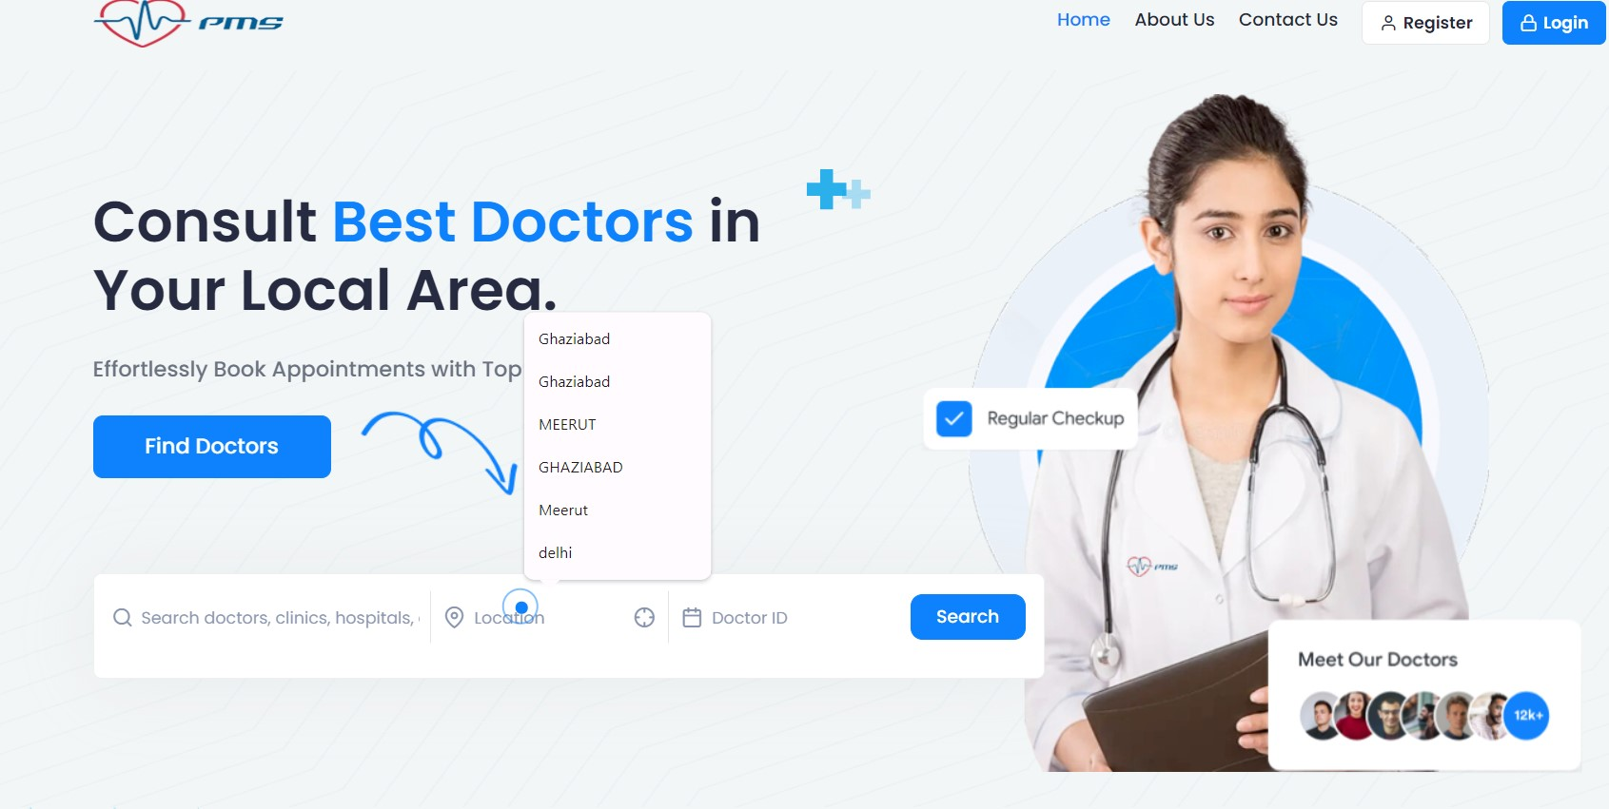

Figure 4.11 Found Doctors from their locations

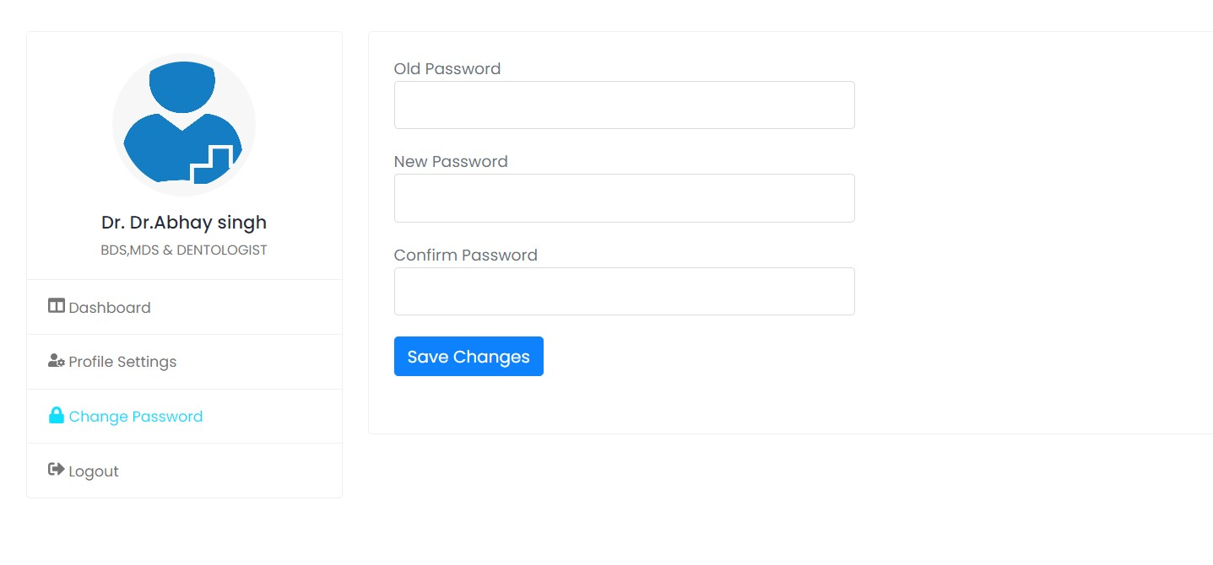

Figure 4.12 Reset password in case of change your password



Figure 4.13 Book website appointment after login of patient



Figure 4.14 Doctors dashboard to check their website appointment

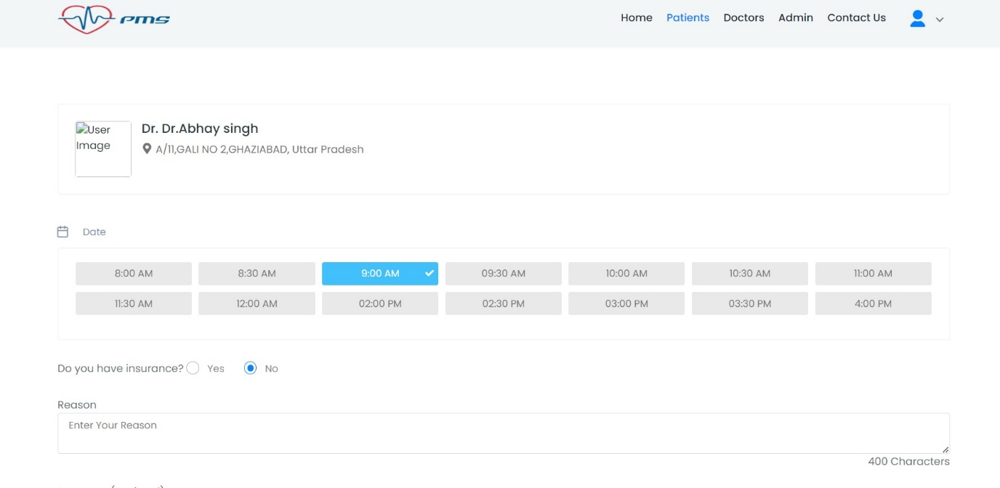

Figure 4.15 Patient book their website appointment acc to shifts and timing after login their profile

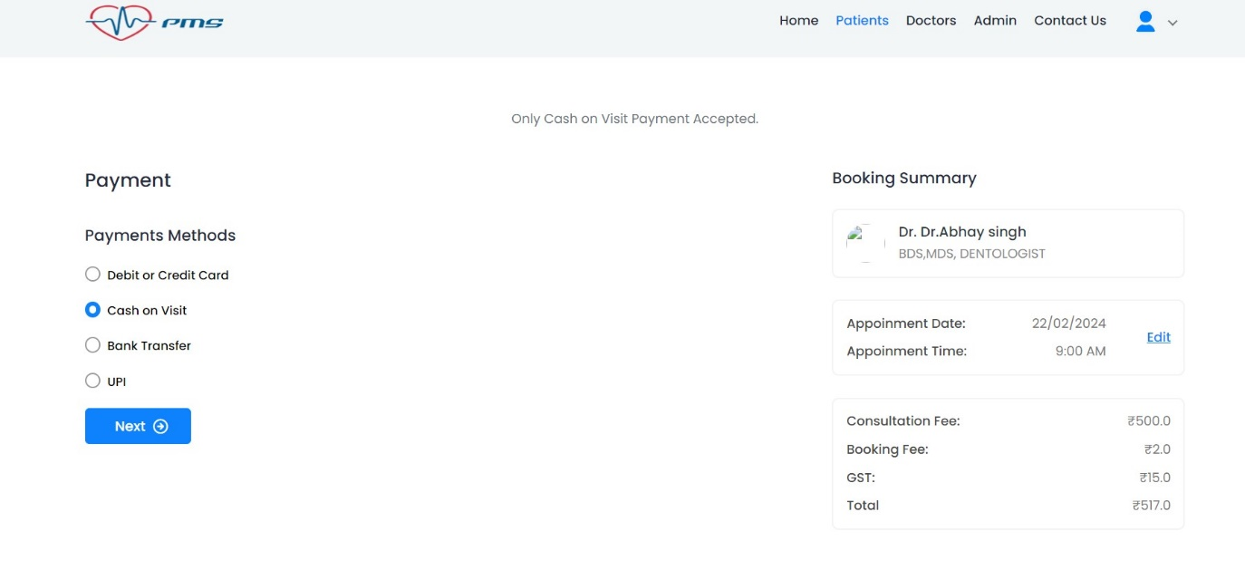

Figure 4.16 Patient can make their payment choosing the payment modes and generate their bill

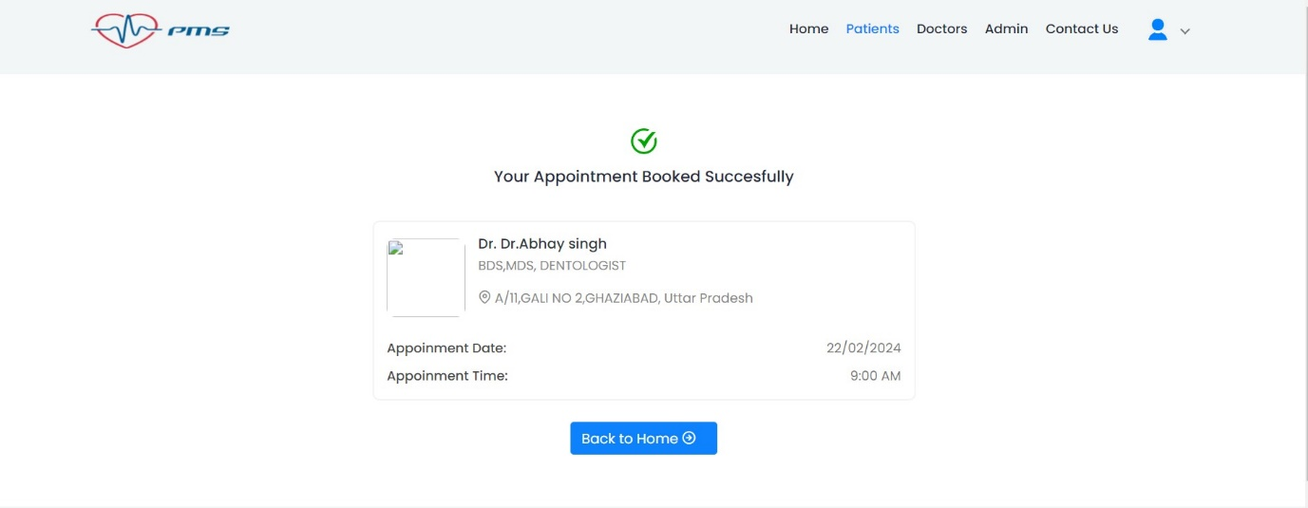

Figure 4.17 Website appointment is successfully done by the patient.

**CHAPTER 5**

**CODING**

**5.1 INTRODUCTION**

Coding serves as the backbone of the Patient Management System, translating the conceptual framework into a functional and interactive software solution. This intricate process involves the implementation of algorithms, data structures, and user interface elements to bring the envisioned features to life. The codebase is meticulously crafted using programming languages such as Python, JavaScript, or others, chosen for their suitability to the project's requirements.

The coding phase encompasses various aspects, including backend logic for user authentication, expense calculations, and database interactions, as well as frontend development for creating an intuitive and visually website user interface. Through diligent coding practices, adherence to coding standards, and continuous testing, the development team aims to produce a robust and reliable Patient Management System that seamlessly aligns with user expectations and operational requirements.

**CHAPTER 6**

**TESTING**

**6.1 INTRODUCTION**

Testing is a critical phase in the development lifecycle of the Patient Management System, serving as a systematic and thorough examination of its functionality, performance, and reliability. This essential process involves evaluating the website features, identifying potential defects, and ensuring that it meets specified requirements. Various testing methodologies, including unit testing, integration testing, and user acceptance testing, are employed to assess different facets of the website. Testing not only validates that each component operates as intended but also verifies the seamless interaction between these components. By rigorously testing the Patient Management System, developers aim to deliver a high-quality product that aligns with user expectations, minimizes the likelihood of errors, and provides a robust and reliable platform for effective shared financial management.

**6.2 Test Case-1**

**6.2.1 Test Case 1: User Registration**

**Objective:** To ensure that users can successfully register for the Patient Management System.

**6.2.1.1 Preconditions:**

* The Patient Management System is accessible and running.
* The user is on the website's registration page.

**6.2.1.2 Test Steps:**

* Enter valid information into the registration form, including a unique email address, a full name, a secure password, and a valid phone number.
* Click on the "Submit" button.

**6.2.1.3 Expected Results:**

* The user should be successfully registered, and a confirmation message should be displayed.
* The user's information, including their email and initial budget, should be stored in the database.

**6.2.1.4 Postconditions:**

* The user should be able to log in using the registered credentials.

**6.3 Test Case-2**

**6.3.1 Test Case 1: Expense Submission**

**Objective:** To verify that users can submit an expense successfully.

**6.3.1.1 Preconditions:**

* The user is logged into the Patient Management System.
* The website is in the "Manual Mode" as per the mode selection.

**6.3.1.2 Test Steps:**

* Navigate to the expense submission form.
* Fill in the necessary details, including selecting a mode, entering a description, and specifying the expense amount.
* Click on the "Submit" button.

**6.3.1.3 Expected Results:**

* The expense should be successfully submitted, and a confirmation message should be displayed.
* The submitted expense details, including the description, amount, and user information, should be stored in the database.

**6.3.1.4 Postconditions:**

* The submitted expense should be visible in the user's expense history.

**BIBLIOGRAPHY**

For the development of the Share Expense web website, a comprehensive set of the has

resources and references has been utilized to ensure effective design, functionality, and user experience. John Smith's book, "Effective Mobile Website Development: Strategies and Best Practices" (2021), served as a foundational guide, providing insights into mobile website development methodologies. Brown's article, "User-Centric Design Principles for Mobile Applications " (2020), from the Journal of User Experience, contributed valuable principles for creating an interface focused on user needs and preferences.

Technical documentation played a crucial role, with Bootstrap's documentation (2022) offering a robust framework for responsive design and W3Schools' guide on "HTML Forms" (2022) aiding in the implementation of user input features. The JavaScript MDN Web Docs' resource on "Introduction to the DOM" (2022) facilitated a deeper understanding of document object model manipulation, enhancing the interactive aspects of the website. jQuery's documentation (2022) provided a concise library for simplifying complex JavaScript functions. The project leveraged external content delivery networks (CDNs) for efficiency, incorporating Bootstrap CDN (2022) and Font Awesome CDN (2022) to optimize the delivery of essential web assets. Additionally, GitHub's documentation on "Version Control with Git" (2022) was a cornerstone for collaborative development, ensuring a streamlined and organized version control process.

These resources collectively shaped the Share Expense web website, aligning it with best practices in mobile website development, user-centric design, responsive web developmsent, and efficient version control. The bibliography reflects a comprehensive website approach, integrating theoretical concepts with practical implementation to deliver a robust and user-friendly expense-sharing platform.

**REFERENCES**

1. W3Schools. (2022). HTML Forms. Retrieved from

<https://www.w3schools.com/html/html_forms.asp>

1. Bootstrap Documentation. (2022). Retrieved from

<https://getbootstrap.com/docs/4.5/getting-started/introduction/>

1. JavaScript MDN Web Docs. (2022). Introduction to the DOM. Retrieved from

<https://developer.mozilla.org/en-US/docs/Web/API/Document_Object_Model/Introduction>

1. jQuery Documentation. (2022). Retrieved from

<https://jquery.com/>

1. Font Awesome Documentation. (2022). Retrieved from

<https://fontawesome.com/v5.15/how-to-use/on-the-web/setup/getting-started>

1. GitHub. (2022). Version Control with Git. Retrieved from

<https://git-scm.com/book/en/v2>

1. Bootstrap CDN. (2022). Retrieved from

<https://www.bootstrapcdn.com/>

1. Font Awesome CDN. (2022). Retrieved from

<https://cdnjs.com/libraries/font-awesome>